|  |  |  |  |  |  |  |  |  |  |  |  |  |  |  |  |  |  |  |  |  |  |
| --- | --- | --- | --- | --- | --- | --- | --- | --- | --- | --- | --- | --- | --- | --- | --- | --- | --- | --- | --- | --- | --- |
|  | **Library Management System**  **Technical Design Document**   |  |  |  |  | | --- | --- | --- | --- | |  | **Prepared By / Last Updated By** | **Reviewed By** | **Approved By** | | **Name** | Ashutosh Ghulaxe (2074584)  Abhishek Verma (2074868)  Anuj Gawande (2074858)  Naman Naresh (2074738)  Shubham Kumar (2074569) |  |  | | **Role** | Team Leader |  |  | | **Signature** | Ashutosh Ghulaxe |  |  | | **Date** | 15/02/2022 |  |  | |
|  |
|  |

**Table of Contents**

**1.0** **Introduction 3**

**1.1** **Purpose of this document 3**

**1.2** **Project overview 3**

**2.0** **Solution Summary 3**

**2.1** **Scope 3**

**2.2** **Assumptions 3**

**2.3** **Dependencies 3**

**3.0** **Schematic Diagram 3**

**4.0** **System Design 4**

**4.1** **Proposed design 4**

**4.2** **Component inventory 4**

**5.0** **Database Design 4**

**5.1** **Data Model 4**

**5.2** **Tables Structure 4**

**6.0** **Appendices 4**

**6.1** **Glossary 4**

**6.2** **Other 5**

**7.0** **Terms & Conditions 5**

**8.0** **Change Log 5**

# Introduction

## Purpose of this document

*The purpose of this document is to document the technical design, component details and Database design. This will also capture the scope, assumptions, risk, dependencies of this project.*

## Project overview

*Library management system*

1. *Library management systems are designed to manage the movement of books and maintain records of the members in a library*
2. *The processes of book indexing, cataloging, book reservations and overdue notifications are automated. The software system makes the process simpler and more accountable.*
3. *This project aims at serving the department of libraries by computerizing the management of library records.*
4. *The system requirement in library management focuses on the possibility of search for books by title, author or subject by the member. They should be able to locate a book physically by the unique identification code and the rack number for each book. The system should provide details on the books held by the members. The system should limit the number of books that can be taken and the number of days that a book can be kept for. The system should generate fines when due from the member. The next step focuses on the functions of the librarian, the member and the system. Managing books by the librarian, searching for books by the members and notifications sent by the system are detailed in a case diagram.*

# Solution Summary

## Scope

*Our project aims at Automating the library management system i.e. we have tried to computerize various processes of library.*

*1. It satisfies the user requirement.*

*2. Easy to understand by the user and operator.*

*3. Easy to operate.*

*4. Have a good user interface*

*5. Delivered on schedule within the budget. We have tried to make such type of software, which satisfies the above given requirement.*

## Assumptions

*Our problem statement deals with management of all the adequate functions with increased efficiency and accuracy along with saving time and manpower. The objective of our project is as follows:*

*a. To keep the information of User.*

*b. To update the extensive database, adding or deleting books or editing the records to make tracking of books an effortless task.*

*c. To keep the information of all the books issued by library.*

*d. To make easy flow for users to search for books at any time from any place.*

## Dependencies

*1. Eclipse IDE*

*2. MYSQL for database*

*3. Tomcat server*

*4. Visual Studio Code*

# Schematic Diagram

*A schematic, or schematic diagram, is a representation of the elements of a*[*system*](https://en.wikipedia.org/wiki/System)*using abstract, graphic symbols rather than realistic pictures. It gives an overview of overall system.*

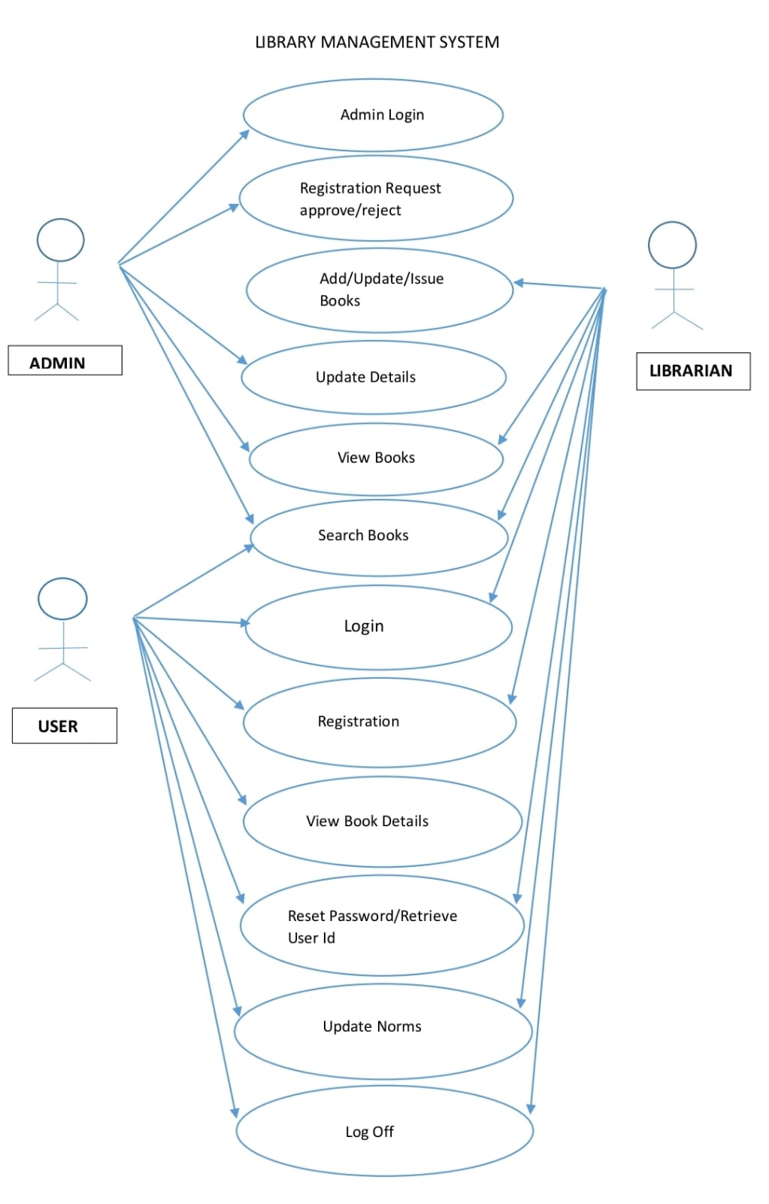

# System Design

## Proposed design

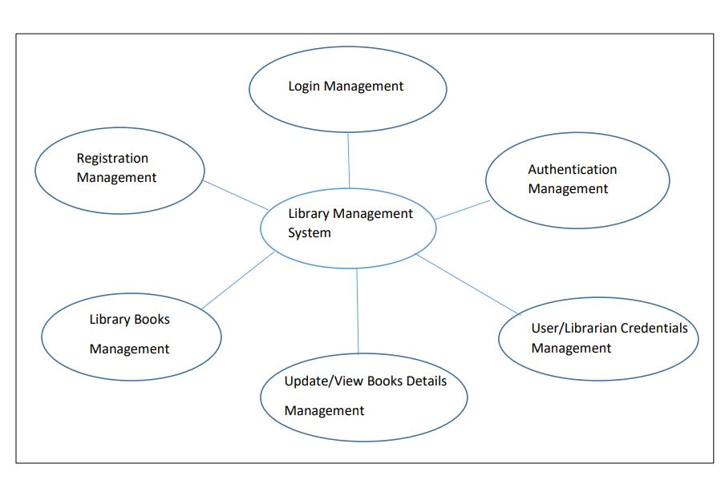

## Component inventory

Model Classes:

* *Admin.java*
* *Bookmodel.java*
* *Librarianmodel.java*
* *Usermodel.java*
* *Login.java*

# Database Design

## Data Model

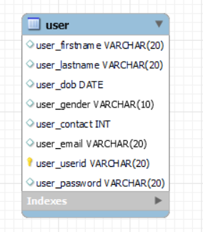

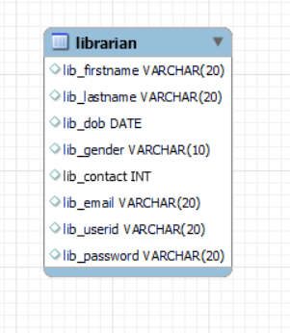

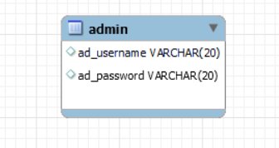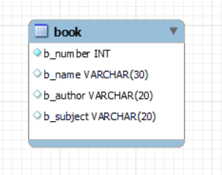

## Tables Structure

* + - 1. *User Details*

|  |  |  |  |
| --- | --- | --- | --- |
| **Column Name** | **Data Type** | **Length** | **Nulls** |
| user_firstname | VARCHAR | 20 |  |
| user_lastname | VARCHAR | 20 |  |
| user_dob | DATE |  |  |
| user_gender | VARCHAR | 10 |  |
| user_contact | INT |  |  |
| user_email | VARCHAR | 20 |  |
| user_userid | VARCHAR | 20 |  |
| user_userpassword | VARCHAR | 20 |  |

* + - 1. *Librarian Details*

|  |  |  |  |
| --- | --- | --- | --- |
| **Column Name** | **Data Type** | **Length** | **Nulls** |
| lib_firstname | VARCHAR | 20 |  |
| lib_lastname | VARCHAR | 20 |  |
| lib_dob | DATE |  |  |
| lib_gender | VARCHAR | 10 |  |
| lib_contact | INT |  |  |
| lib_email | VARCHAR | 20 |  |
| lib_userid | VARCHAR | 20 |  |
| lib_userpassword | VARCHAR | 20 |  |

* + - 1. *Book Details*

|  |  |  |  |
| --- | --- | --- | --- |
| **Column Name** | **Data Type** | **Length** | **Nulls** |
| b_number | INT |  |  |
| b_name | VARCHAR | 30 |  |
| b_author | VARCHAR | 20 |  |
| b_subject | VARCHAR | 20 |  |

*4. Admin Details*

|  |  |  |  |
| --- | --- | --- | --- |
| **Column Name** | **Data Type** | **Length** | **Nulls** |
| ad_username | VARCHAR | 20 |  |
| ad_password | VARCHAR | 20 |  |

# 6.0Appendices

## Glossary

|  |  |
| --- | --- |
| **Acronyms** | **Definitions** |
|  |  |

## Other

# Terms & Conditions

***Disclaimer: Please do not circulate or distribute this document outside of Cognizant Network, We have a Zero Tolerance Policy. Kindly adhere to 100% Compliance at all times.***

# Change Log

*Please note that this table needs to be maintained even if a Configuration Management tool is used.*

|  |  |  |  |  |
| --- | --- | --- | --- | --- |
| **Version Number** | **Changes made** | | | |
| V<n.n> | *<If the change details are not explicitly documented in the table below, reference should be provided here>* | | | |
| Page no | Changed by | Effective date | Changes effected |
|  |  |  |  |
|  |  |  |  |
|  |  |  |  |
|  |  |  |  |